

Lab # 9

PF Lab Task

Submitted by: **Maira Emaan Nasir**

Roll no: 2430-0153

Department: **BSCS**

Submitted to: **Sir Bilal Dar**

Date: 30/11/2024

Task: 01

Code:

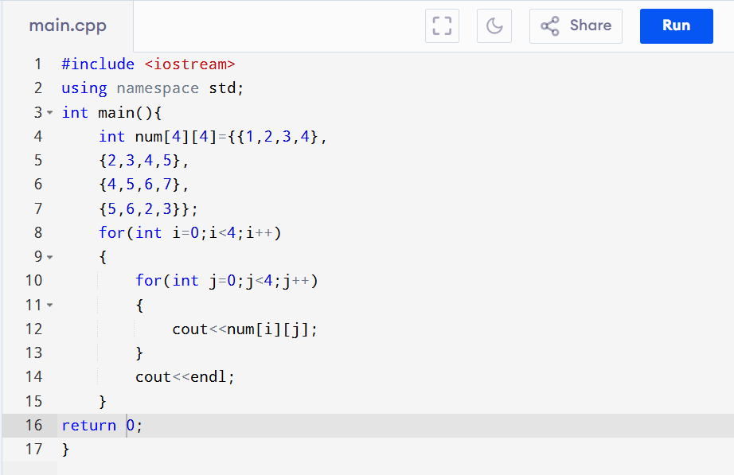

Output:

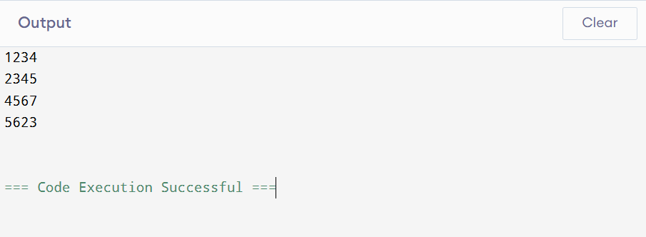

Task: 02

Code:

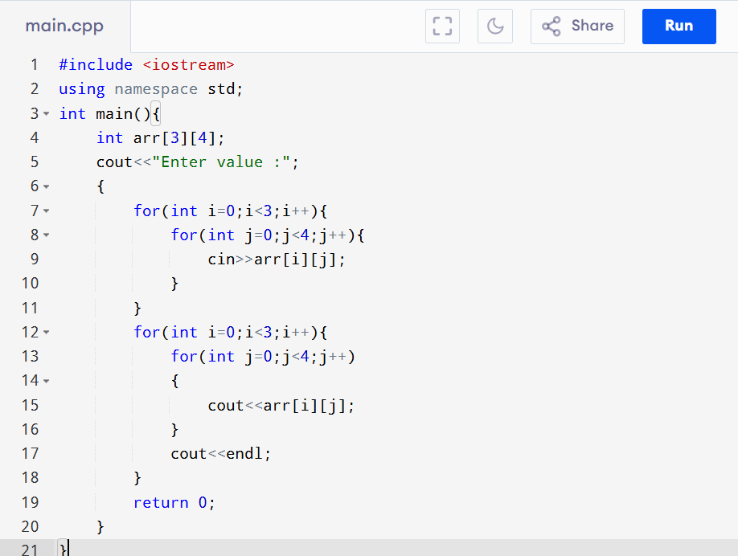

Output:

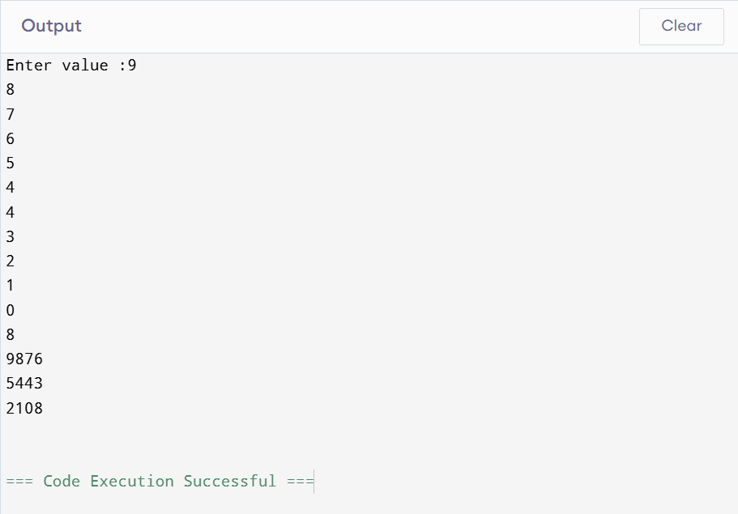

Task: 03

Code:

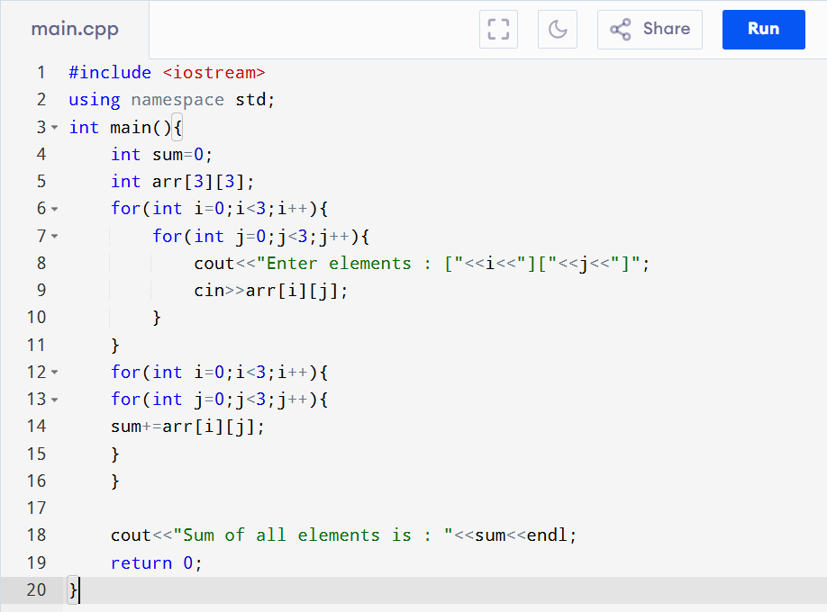

Output:

